Jonathan Riley

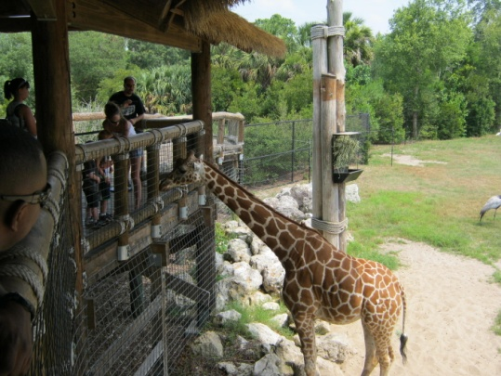**Is it morally wrong to keep animals captive in zoos?**

Short answer is yes and no. While taking animals out of their environment and placing them in the confines of an enclosed zoo area may seem very wrong, it does have some positive points that need to be reviewed. Such as;

1. Most of the animals kept in zoos were generally breed in captivity so they really know nothing else. This makes it less damaging on the animal than plucking them from the wild and placing them in enclosed areas.
2. Having zoos keep animals allows for the younger generation of society to experience and be educated about them which promotes conservation.
3. A lot of the funds for admission into such institutions go to wild-life conservation organizations/programs and to the further biological and conservation studies of such species.
4. A large majority of the animals held in zoos now are either extinct or near extinct in the wild. So having them in captive programs allows for breeding programs that help perpetuate the species longevity and keeps them from disappearing from the planet entirely.
5. Zoos provide an “easy” life for the animals in that they receive medical care, steady diet and nutrients, and socialization with other like species that they may never receive in the wild.
6. 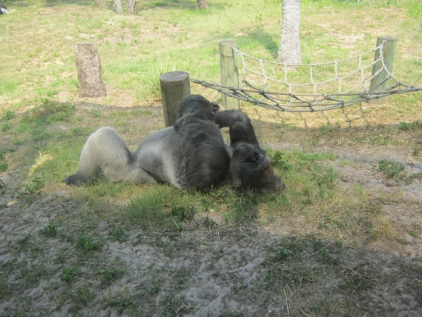Depending on the institution, many zoos provide as close to natural environments as possible for their vast collection of animals. While their enclosures are certainly not as wide-spanning as their nature environment, the effort put into maintaining and designing enclosures based on the species natural environments help make them feel at home as well as educating the general population as to the conditions of their native lands. Thereby promoting further conservation not only of the species but of the environments in which are naturally found in.

***Negative Aspects can be defined as such;***

1. 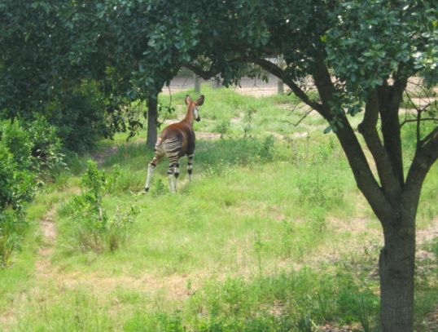Keeping any species in an enclosed area has potential negative physical and mental effects. Take the animals that pace back in forth in a small enclosure which is very similar to human behavior observed in a prison type environment.
2. Most of the enclosures that hold the animals are not even close to the natural range of each animal and therefore perpetuates the issues listed above.
3. 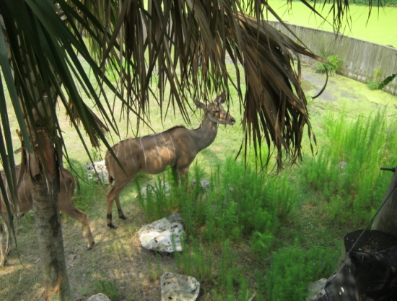Larger animals are given more emphasis due to the fact that these are the animals that bring in more visitors and therefore more revenue for the institutions that house them.
4. Since the animals are completely cared for by man, there is no chance for most to ever be re-acclimated into the wild. The animals never achieve the necessary survival skills to live on their own and therefore become completely dependent on man.
5. The exploitation of these animals by putting them on display for the masses is very controversial to many people. However it is really the safest way for large groups of people of all ages and social statures to be able to participate in the education and conservation of such wildlife.

So as you can see from this, keeping animals in Zoos is definitely a so-so proposition which falls under the majority rule that allows it. If you truly care about the condition and well-being of other species then making donations, volunteering, and simply visiting these type of institutions not only helps perpetuate the species . . . it may just open your mind to so much more.